Name: Silence

Slogan: Silence will fall

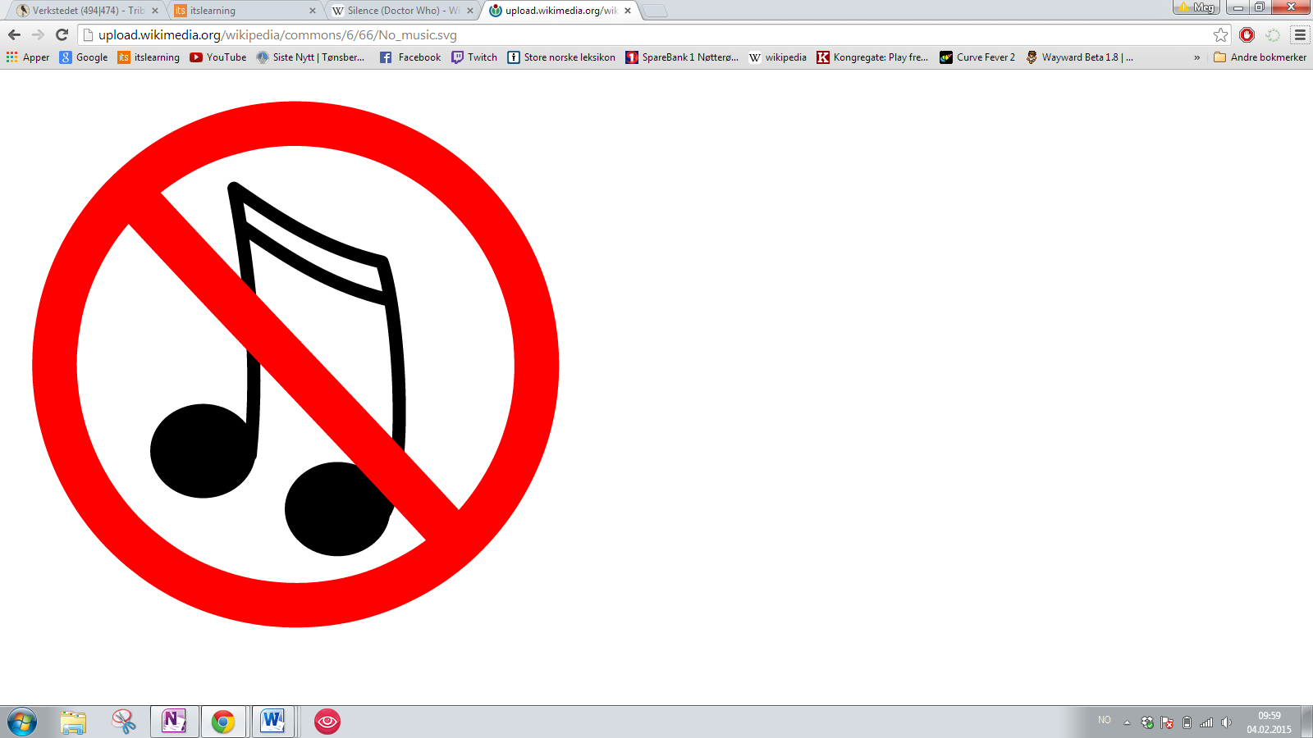

Sub-text: When the question is asked silence will fall. We work for a better and more relaxing experience at shopping malls, stores, restaurants, etc. the only thing allowed is the theme of the doctor. All else shall be exterminated and deleted.